
Vidyavardhini’s College of Engineering & Technology
Department of Computer Science & Engineering (Data Science)

NAME : Samar Santosh Sawant
Div : SE3-B2
Roll No: 35 Branch : CSE-DS Experiment No : 3
DOP (Date of Performance):
02/02/26
DOC (Date of Completion):
16/02/26
Experiment Title : Create a dynamic To-Do List where users can add, mark as complete, and remove tasks using JavaScript &amp; DOM.
AIM : To design and develop a dynamic To-Do List application using JavaScript and DOM manipulation that allows users to add tasks, mark tasks as completed, and delete tasks interactively in real time.

PROGRAM:
<!DOCTYPE html>
<html lang="en">
<head>
<meta charset="UTF-8">
<title>Modern To-Do List</title>

<style> body {
font-family: "Poppins", sans-serif; background: #f4f4f4;
display: flex;
justify-content: center; padding-top: 50px;
}
/* ✨ Fancy Glass Card */
.container { width: 380px; padding: 25px;
border-radius: 20px;
background: rgba(255, 255, 255, 0.7); backdrop-filter: blur(12px);
box-shadow: 0 15px 35px rgba(0,0,0,0.15); transition: 0.3s ease;
}
.container:hover {
transform: translateY(-5px);
box-shadow: 0 20px 40px rgba(0,0,0,0.20);
}
h2 {
text-align: center; margin-bottom: 20px; font-weight: 600;
color: #333;
letter-spacing: 1px;
}
/* 🔹 Input + Button Row */
.input-section { display: flex; gap: 10px; }
#taskInput { flex: 1; padding: 12px; border: none;
border-radius: 14px; background: #ffffff;
box-shadow: inset 0 0 8px rgba(0,0,0,0.08); font-size: 14px;
outline: none; transition: 0.2s;
}
#taskInput:focus {
box-shadow: 0 0 0 2px #74b9ff;
}
/* ✨ Better Button */ #addBtn {
padding: 12px 20px; border: none; cursor: pointer; border-radius: 14px;
background: linear-gradient(135deg, #6a5af9, #795df5); color: white;
font-weight: bold; font-size: 14px; transition: 0.3s;
}
#addBtn:hover {
background: linear-gradient(135deg, #5848d4, #6a50e7); transform: scale(1.05);
}
/* Task List */ ul {
margin-top: 20px; padding: 0;
}
ul li {
list-style: none; padding: 14px;
margin-bottom: 12px; background: #ffffff; border-radius: 14px; display: flex;
justify-content: space-between; align-items: center;
box-shadow: 0 3px 12px rgba(0,0,0,0.08); transition: 0.3s;
cursor: pointer; font-size: 15px;
}
ul li:hover {
transform: scale(1.02); background: #fafafa;
}
li.completed {
text-decoration: line-through; color: #777;
background: #eaf3ff;
}
/* Delete Button */
.remove-btn { padding: 6px 10px; border: none; border-radius: 10px;
background: #ff6b6b;
color: white; cursor: pointer; font-size: 12px; transition: 0.25s;
}
.remove-btn:hover { background: #e63946; transform: scale(1.1);
}
</style>
</head>

<body>

<div class="container">
<h2>✨ My Tasks</h2>
<div class="input-section">
<input type="text" id="taskInput" placeholder="Add your task...">
<button id="addBtn">Add</button>
</div>
<ul id="taskList"></ul>
</div>
<script>
const addBtn = document.getElementById("addBtn"); const taskInput = document.getElementById("taskInput"); const taskList = document.getElementById("taskList");
addBtn.addEventListener("click", addTask); function addTask() {
const taskText = taskInput.value.trim(); if (taskText === "") {
alert("Please enter a task!"); return;
}
const li = document.createElement("li"); li.textContent = taskText;

li.addEventListener("click", function () { li.classList.toggle("completed");
});

const removeBtn = document.createElement("button"); removeBtn.textContent = "✖"; removeBtn.classList.add("remove-btn");

removeBtn.addEventListener("click", function (event) { event.stopPropagation();
taskList.removeChild(li);
});

li.appendChild(removeBtn); taskList.appendChild(li);
taskInput.value = "";
}
</script>

</body>
</html>

OUTPUT:
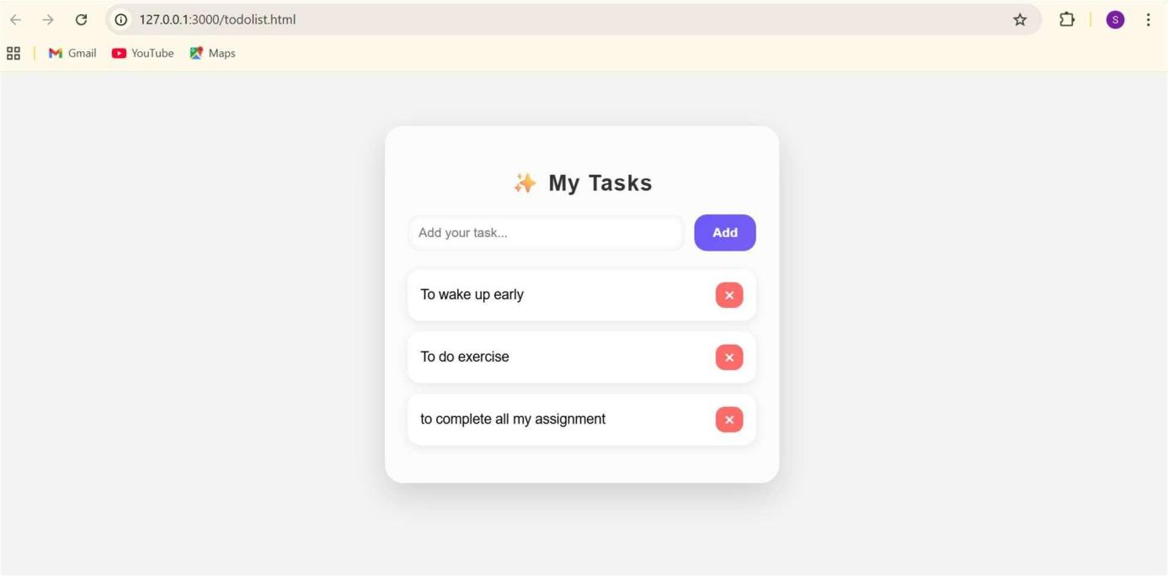
DELETING TWO TASKS
